**ECE170B Project 2**

Start date: **February 28, 2020**

Due Date: **March 12, 2020 by 5pm**

**Instructions:** You will use Matlab for this project. **It is required that you use the Livescript tool and type your answers as text and equations in Livescript and turn in the .mlx file as your homework.**

**Submission**: You will submit your file(s) online using CCLE. There will be an assignment sub-folder with the Project Name (e.g. Project 2)

Project 2 part 1: Chromo Modal Dispersion (CMD)

Background: Chromodal dispersion achieve very high and tunable group velocity dispersion using a multimode waveguide (e.g. MM fiber). It uses a diffraction grating to separate different colors and launch them at different angles into a multimode waveguide. In this way different color travel through different modes which have different delays. Hence wavelengths are dispersed in time. More information about this technology can be found in the following publication:

Diebold, Eric D., et al. "Giant tunable optical dispersion using chromo-modal excitation of a multimode waveguide." *Optics express* 19.24 (2011): 23809-23817.

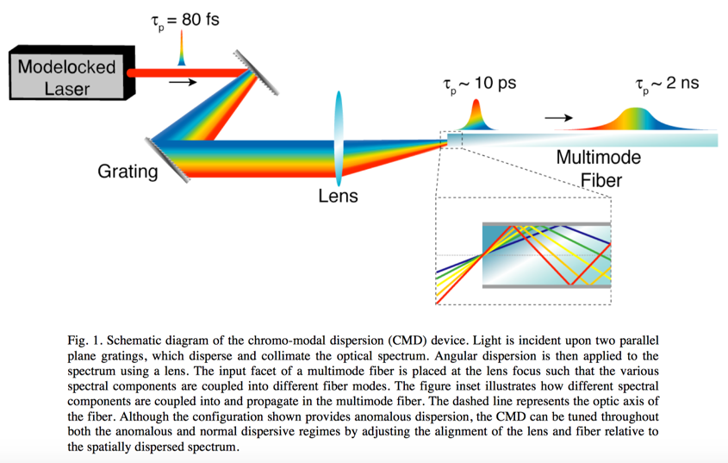

The dispersion behavior of CMD can be modeled using the conventional Taylor expansion for the phase vs. angular frequency:

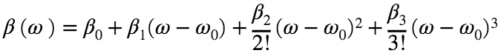

treat as the phase for the entire length of the fiber. Then the group delay is given by:

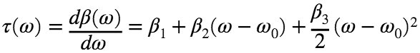

Problem: The file *CMD_Group_Delay.csv* contains measurement of the group delay vs. wavelength. The units are indicated in the column headers. The length of the multimode fiber was 20 meters. You can assume that the fiber core is made of glass with refrative index n-1.5. Use Matlab Livescript (.mlx file format) to:

(a) Obtain the values of 

Hint: First convert the group delay to phaes, i.e. then do a polynomial fit using the *polyfit* function in Matlab. You will need to figure out how to calculate 

(b) Calculate the dispersion coefficient, D. Hint; D has units of time per incremental wavelength: ps/nm

(c) Plot the data and the polynomial fit for delay vs. wavelength.

(c) Plot the data and the polynomial fit for delay vs. frequency, g.

(d) Assume the fiber forms a resonator with R=0.99. Plot the intensity spectrum vs. frequency.

Project 2 part 2: Silicon's Group Delay Dispersion

In this problem, you will analyze silicon's refractive index and material dispersion behavior.

(a) Download the refracive index vs. wavelength for silicon, into a .csv file, from the website *refractiveindex.info*.

(b) Convert that to beta vs. omega and fit it to a poynomial to obtain the dispersion coefficients, 

(c) Calculate the dispersion parameter, D. Hint: D has units of time per incremental wavelength

**Definitions of dispersion parameters:**

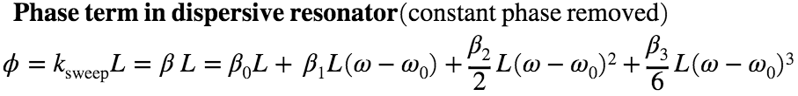

**Definitions of dispersion parameters:**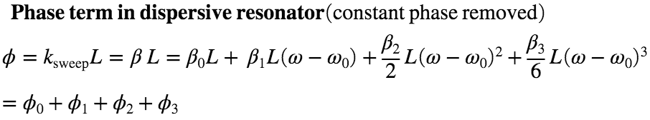

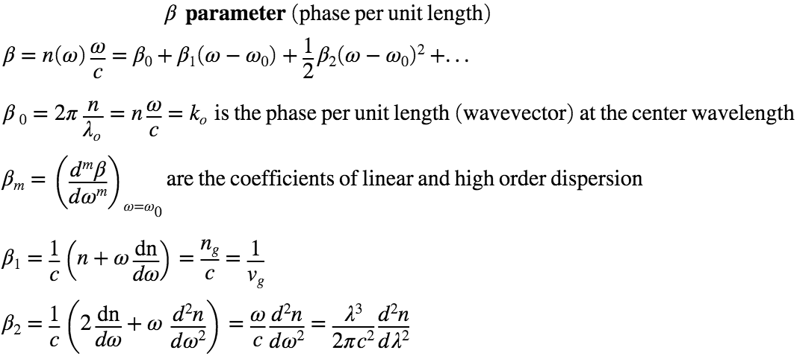

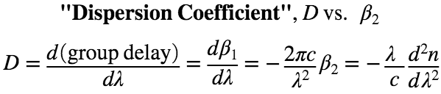

**Helpful Resources**

**Dispersion:**

1. Class notes
2. <https://en.wikipedia.org/wiki/Group_velocity>
3. <https://en.wikipedia.org/wiki/Group_velocity_dispersion>
4. <https://paginas.fe.up.pt/~hsalgado/co/docs/phase_group_vel_dispersion.pdf> (has the derivation of dispersion penalty)
5. **Access to Matlab**
6. You will be using MATLAB in this class and need a SEASNET account.
7. <https://softwarecentral.ucla.edu/matlab-getmatlab>
8. **Matlab Resources**
9. See the Syllabus, also for Fourier Transform, see: